The Five Ways to Wellbeing were developed from evidence gathered in a UK government project. The Project drew on state-of-the-art research about mental capital and mental wellbeing through life. The Five Ways to Wellbeing are based on findings from this project and are a set of evidence-based actions which promote people’s wellbeing.

These activities are simple things individuals can do in their everyday lives. The concept of wellbeing comprises two main elements: feeling good and functioning well. Experiencing positive relationships, having some control over one’s life and having a sense of purpose are all important attributes of wellbeing.

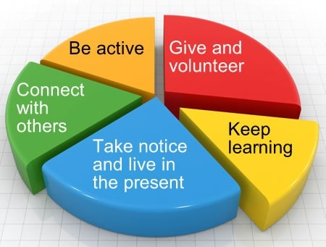
Connect…
With the people around you. Think of these as the cornerstones of your life and invest time in developing them. Building these connections will support and enrich you every day.
There is strong evidence that indicates that feeling close to, and valued by, other people is a fundamental human need and one that contributes to functioning well in the world.
● Talk to someone instead of sending an email ● Speak to someone new ● Ask how someone’s weekend was and really listen when they tell you ● Put five minutes aside to find out how someone really is

Be active…
Go for a walk or run. Step outside. Cycle. Play a game. Garden. Dance.
Regular physical activity is associated with lower rates of depression and anxiety across all age groups.
But it doesn’t need to be particularly intense for you to feel good - slower-paced activities, such as walking, can have the benefit of encouraging social interactions as well providing some level of exercise.
● Take the stairs not the lift
● Go for a walk at lunchtime
● Walk into work - perhaps with a colleague – so you can ‘connect’ as well
● Walk to someone’s desk instead of calling or emailing.

Take notice…
Be curious. Catch sight of the beautiful. Remark on the unusual. Notice the changing seasons. Be aware of the world around you and what you are feeling. Reflecting on your experiences will help you appreciate what matters to you.
Studies have shown that being aware of what is taking place in the present directly enhances your well-being and savouring ‘the moment’ can help to reaffirm your life priorities.
● Get a plant for your workspace
● Take in the sun on your face and the smell of the grass
● Take a different route on your journey to or from work
● Visit a new place for lunch.

Keep learning…
Try something new. Rediscover an old interest. Sign up for that course. Take on a different responsibility at work. Fix a bike. Learn to play an instrument or how to cook your favourite food. Set a challenge you will enjoy achieving. Learning new things will make you more confident as well as being fun.
The practice of setting goals, which is related to adult learning in particular, has been strongly associated with higher levels of wellbeing.
● Sign up for a class
● Read the news or a book
● Do a crossword or Sudoku
● Research something you’ve always wondered about

Give…
Do something nice for a friend, or a stranger. Thank someone. Smile.
Volunteer your time. Join a community group. Look out, as well as in.
Seeing yourself, and your happiness, linked to the wider community can be incredibly rewarding and creates connections with the people around you.
Research into actions for promoting happiness has shown that committing an act of kindness once a week over a six-week period is associated with an increase in wellbeing.

